Assignment 6

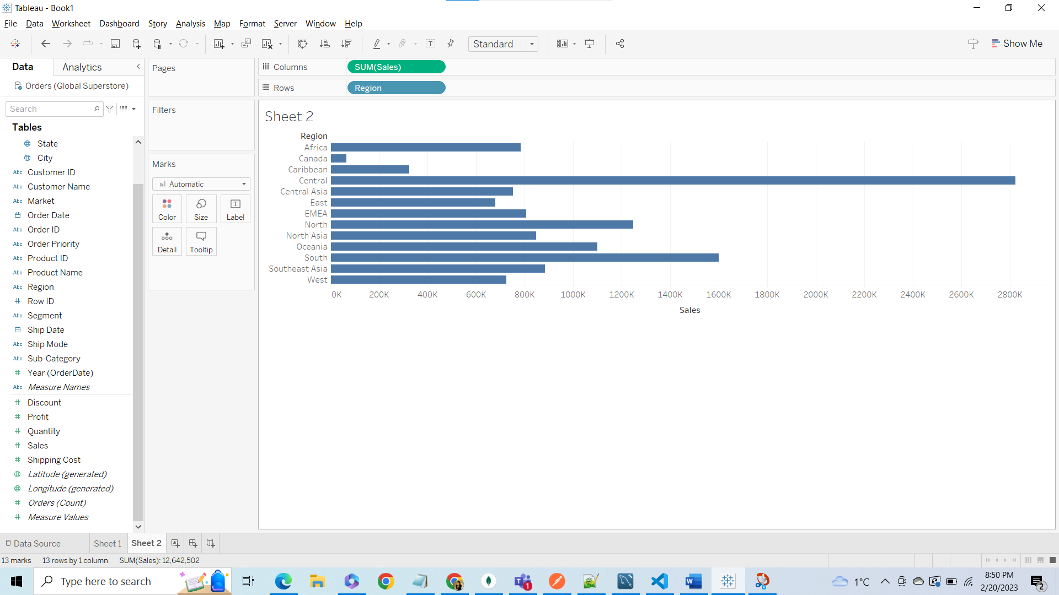

Sort Sum of Sales within Region by descending order.

